**Category 6A Unshielded Keystone Jack**

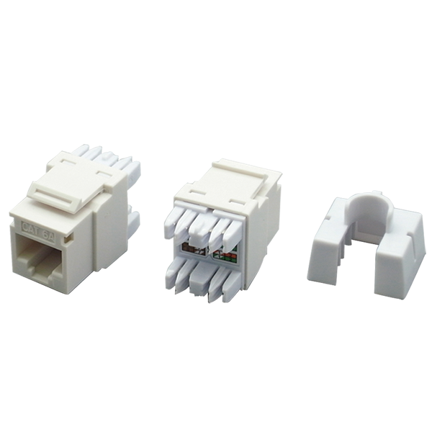

Category 6A unshielded keystone jack supports the 10/100/1G BASE-T Ethernet, as well as advanced 10G BASE-T Ethernet, meets and exceeds ANSI/TIA-568.2-D and ISO/IEC 11801 2nd edition standards. By special designed housing and installation the jacks on a staggered 24-port 1U patch panel, it minimizes additional AXT from neighboring connectors, and provide transmission performance beyond 500MHz and Alien crosstalk requirements.

## **Features**

Contacts are phosphor bronze plated with 50 micro inches hard gold

Dual T568A &amp; T568B wiring

Polycarbonate 94V0 rated

Itertek ETL / Force EC Cat.6A VERIFIED

4PPoE compliant in accordance with IEEE802.bt Type 4

**Ordering Information**

|  |  |
| --- | --- |
| **Part No.** | **Description** |
| **1A68TP0A0-XX** | RJ45, 8-Conductor Cat.6A , Tool-free, Unshielded, 180 degree, H.D. version |
| **1A68IP0A0-XX** | RJ45, 8-Conductor Cat.6A , 110 IDC, Unshielded, 180 degree, H.D. version |
| **0A68IP0A0-XX** | RJ45, 8-Conductor Cat.6A , KRONE/110 IDC, Unshielded, 180 degree, H.D. version |
| **6A68TP0A0-XX** | RJ45, 8-Conductor Cat.6A, Tool-free, Unshielded, 180 degree. |
| **7B68TP0A0-XX** | RJ45, 8-Conductor Cat.6A , Tool-free, Unshielded, 180 degree, H.D. version |
| **1C68TP0A1-XX** | RJ45, 8-Conductor Cat.6A , Tool-free, Unshielded, 180 degree, H.D. version, no cable tie required |
| **1T68TP0A0-XX** | RJ45, 8-Conductor Cat.6A , Tool-free, Unshielded, 90 degree, H.D. version, L=35.0mm |

***“XX” = Color choices – Ivory (IV), White (WH), Grey (GY), black (BK), Red (RD), Orange (OR), Blue (BL), Green (GN), Yellow (YL)***